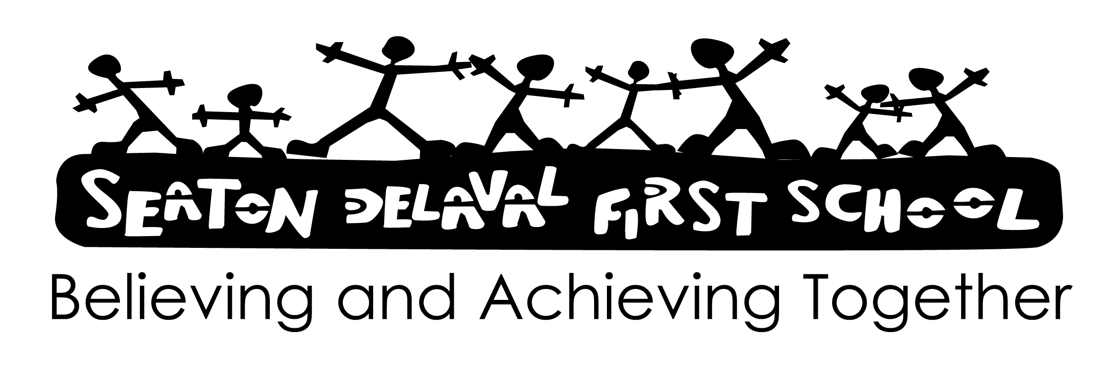

**Signed: Mrs C Vallely**

**Date: September 2024**

**Review: September 2026**

**MUSIC POLICY 2024-2026**

This policy is consistent with the whole school aims and takes account of the New National

Curriculum requirements. Every child is entitled to receive the best education possible and

achieve the highest standards, regardless of ability, disability, gender, social or ethnic

background. To pursue high academic standards through the provision of a broad and balanced

curriculum which:

* Serves the needs of all children
* Motivates children to have high expectations and self-esteem
* Stimulates and challenges
* Involves practical and first hand experiences
* Complies with the legal requirements of the National Curriculum and the Early Years Foundation
* Stage
* Is continuous and progressive
* Has built in monitoring, evaluation and review procedures
* Children should have a short weekly music sessions covering various areas of the curriculum. .

**We aim to support the teaching of music in Early Years Foundation Stage by:**

* Enabling children to build up a repertoire of songs, making music and dance and experimenting with ways of changing them.
* Explore the sounds that different instruments can make.
* Joining in with familiar songs and dances.
* Creating and copying simple rhythms.
* Listening to rhyme in music.
* Singing as part of daily routines and expectations.

**We aim to support the teaching of music in Key Stage 1 by providing opportunities for**

**children to:**

* Use their voices expressively by singing songs and speaking chants and rhymes
* play tuned and un-tuned instruments with guidance.
* Explore elements such as tempo, rhythm and pitch with instruments.
* Listen with concentration and understanding to a range of high quality live and recorded music
* Experiment with, create, select and combine sounds using the inter-related dimensions of music.
* Create and perform music in cross-curricular ways; including stories.

**We aim to support the teaching of music in Key Stage 2 by providing opportunities for**

**children to:**

* Sing and play musically with increasing confidence and control. They should develop an
* Understanding of composition, organising and manipulating ideas within musical structures and
* Reproducing sounds from aural memory.
* Play and perform in solo and ensemble contexts, using their voices and playing musical instruments with increasing accuracy, fluency, control and expression.
* Improvise and compose music using the inter-related dimensions of music
* Listen with attention to detail and recall sounds with increasing aural memory
* Use ICT and other media to record and create music
* Appreciate and understand a wide range of quality live and recorded music from different traditions and from great composers and musicians
* Develop an understanding of the history of music in the music curriculum.
* Learn about music and musical traditions from other cultures.

**Differentiation**

Activities are differentiated through outcome and levels of support provided as well as through

the range of different but related tasks, which are given according to levels of ability. Differentiation of planning is used from the ‘Charanga’ music scheme.

**Mastery**

Children should be given sufficient opportunities to apply their learning and deepen their

knowledge skills and understanding in a variety of contexts.

**Assessment & Record Keeping**

Informal assessment is on-going with verbal feedback and adult support is an integral part of

lessons. Some music lessons are recorded for staff to assess and children to evaluate their own performances.

**Cross-curricular Links**

Wherever possible the music planned for a term links to other subject areas taught at that

time. Music and songs appropriate to topics and songs from other cultures and varying genres will also be covered. Classes will use music in PE lessons, sing in assemblies, as part of English and maths work as well as in class performances.

**Use of IT**

Children have opportunities to produce their own work, listening to various composers and

genres, and can access the internet to research various works, use ipads to record their work and performances.

**Resources/Storage**

There are a range of instrumental resources including access to musical instruments stored on the music trolley. We also plan and use music resources from ‘Charanga’ that provides in depth planning, differentiation and outcomes by year group. This enables staff to follow step-by step weekly music lessons showing progression, with opportunities to assess informally throughout the year.

**Evaluation**

This policy and related scheme of work will be evaluated and reviewed annually.

The subject lead for Music is Mrs Vallely