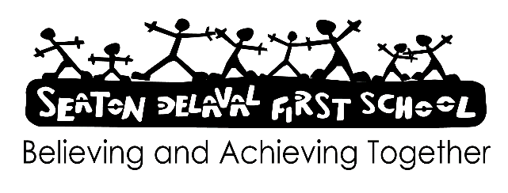

Date: September 2024

Reviews: September 2026

Statement

We believe that the study of Geography should inspire a curiosity and fascination about the world, enabling children to make sense of their surroundings. It is concerned with the study of diverse places, people, resources and of the formation and use of landscapes and environments. Their growing knowledge about the world should help them deepen their understanding of the interaction between physical and human process.

Equal Opportunities

We believe that all children at Seaton Delaval First School should have equal access to the geography National Curriculum. We feel it is important to be sensitive to issues of gender and disability.

Through a careful choice of materials and sensitive teaching we aim to avoid cultural stereotyping and produce a culturally balanced view of Geography.

Aims

We aim to meet the requirements of the National Curriculum for Geography through:-

* Develop contextual knowledge of the location of globally significant places that are both terrestrial and marine – including their defining human and physical characteristics.
* Understand the processes that give rise to key physical and human geographical features of the world, how these are interdependent and how they bring about spatial variation and change over time.
* Enhancing the children’s sense of responsibility for the care of the environment
* Helping to develop the children’s geographical knowledge, understanding and vocabulary through the collection and analysis of data gathered through fieldwork.
* Interpret a range of sources including maps, diagrams and aerial photographs.
* Introducing the children to the skills, equipment and resources, which will help them with geographical enquiry (becoming more independent as they progress through school).
* Using appropriate ICT to bring Geography to life, where possible.

Teaching

In order to deliver the Geography curriculum, we use a variety of teaching styles appropriate to the tasks and activities in hand. These include whole class teaching, small group work and individual work. Whenever possible we attempt to give the children first-hand experience of places with particular emphasis on using our locality to develop the geographical awareness. We aim to encourage the children to express their own views on the environment and try to get them to verbalise their thoughts on the physical and human characteristics of places.

Mastery.

Children will be encouraged to develop skills that can be applied across all areas of Geography.

Mastery will include researching and developing enquiry leading to deep geographical

understanding.

Progression

In order to provide our children with an organised and balanced curriculum, the school scheme plans for continuity and progression in each key stage through increasing –

A) The breadth of studies covered

B) The content covered

C) The spatial scale of study

D) The opportunities for the children to examine more complex social/environmental issues

E) The vocabulary content of activities

F) The use of field work skills and secondary sources of information

Planning and assessment

The teaching of Geography will be delivered by teachers who will choose appropriate areas which fulfil the requirements of the National Curriculum. As result of this, the Geography curriculum throughout our school may not be spread uniformly through a week, a term or year, but an adequate amount of time will be allocated over the year and Key Stage.

The assessment of Geography is seen as an integral part of the planning process and occurs informally as the teacher is talking to the children, observing them at work and marking.

Geography in the Foundation stage is covered by the U.T.W. aspect of the guidance for that stage.

The topics relate to finding out about their environment and looking at features of the natural world.