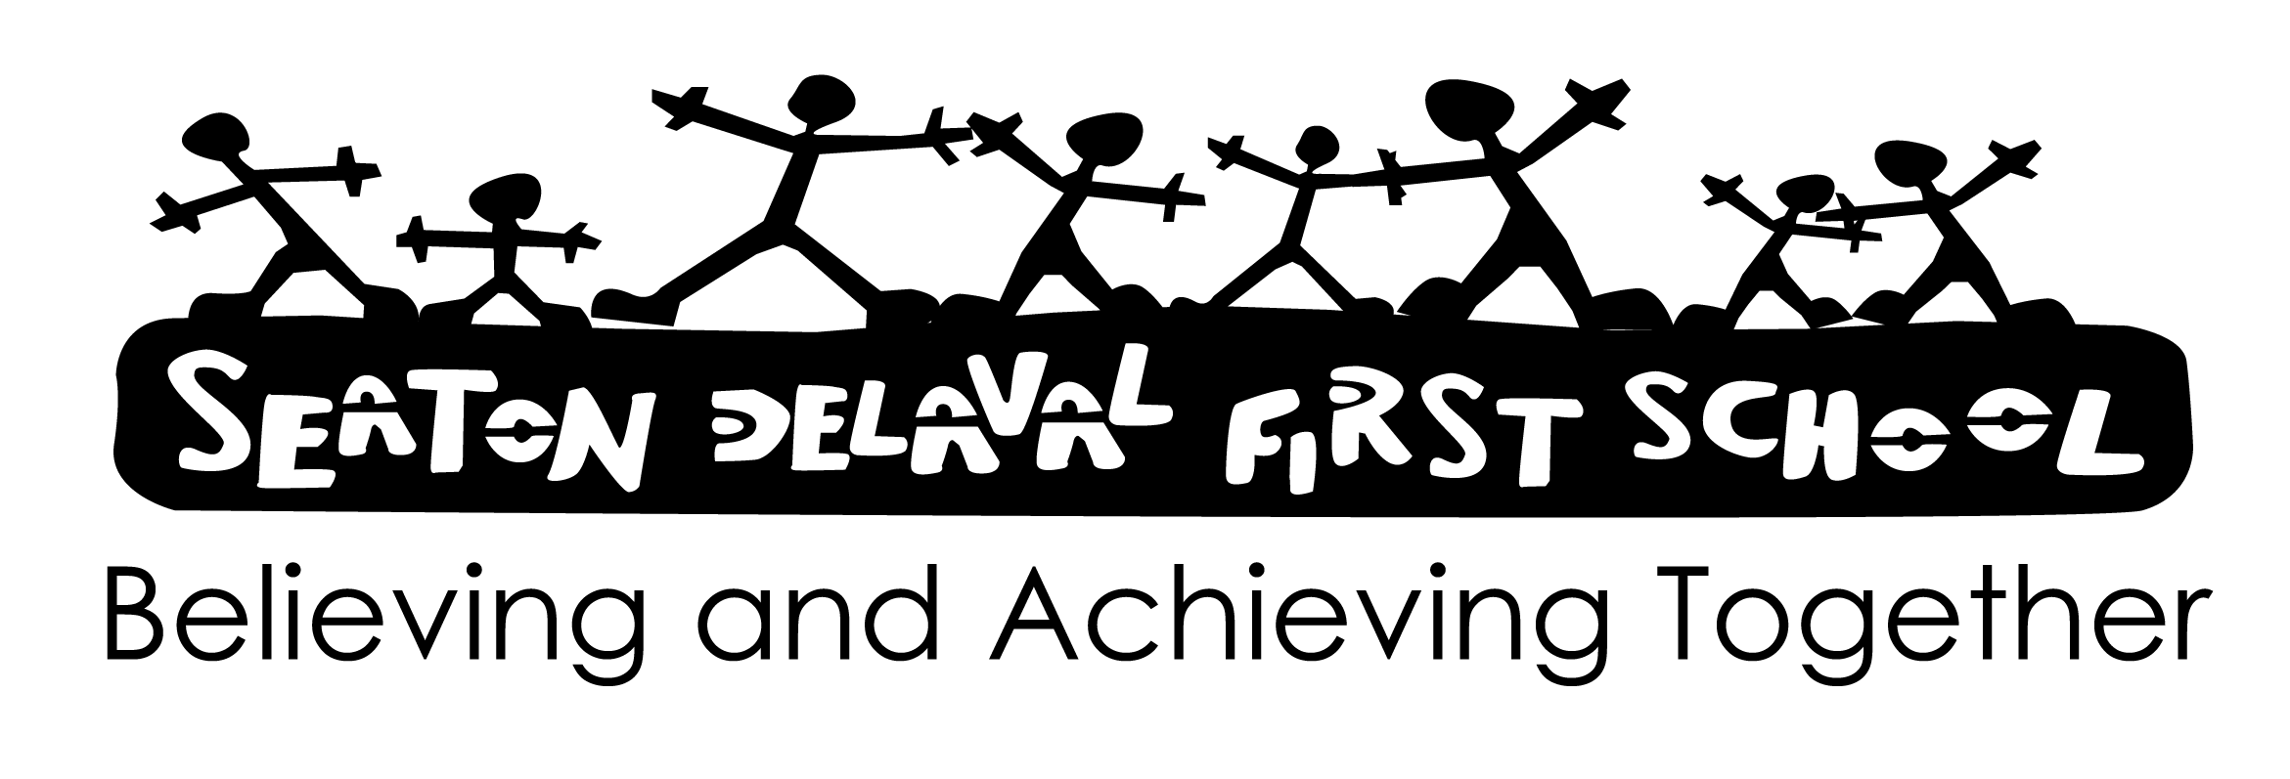
Date: November 2024
Review: November 2026
Signed:

Reading Policy.

We consider that reading is the most important thing that a child can learn in our School. It is the key that opens all other Curriculum areas. To this end we operate a variety of methods in the school. Oxford Reading Tree is the basic Reading scheme around which the formalised reading takes place but alongside this scheme the children are encouraged to read a variety of fictional and non-fictional texts.

Aims:
- To enable children to read confidently and fluently, both for pleasure and to use and access information.
- To create an environment in which children feel that reading is an essential and natural means of communication.
- To make reading an activity that is fun and enhances enjoyment.
- To teach the knowledge and skill of ‘reading’ through using phonics as a prime strategy for reading and spelling.

Teaching strategies:
Each class will have a collection of well-chosen books that include picture books, poetry, folk tales, fairy stories, stories from other cultures and factual books.
English lessons will introduce texts in other contexts – letters, journals, Newspapers, Magazines, etc.
Children in Key Stage 1 and 2 have a daily Basic Skills lesson to teach, practise or apply.
The afternoon session begins daily with an adult reading a story to pupils across the school. EYFS pupils have a story before they go home.

Every child in school has;
- A reading book, from the scheme, which must be discussed and changed with the teacher.
- A library book, which is intended, for shared reading with someone else and which may be changed as often as the child wishes.
- A Home-school diary, which records their progress and which parents, teachers and children make comments in. (The children start to write their own comments in Year 3 and 4.) Parents of children in Reception, Y1 and Y2 are expected to sign the diary each time that they hear their child read. A sticker is attached to a child’s book-marker when they have read 5 times at home in numbered spaces; when the book-mark is completed with stickers a reward is chosen by the child.

All children in school are:
Asked to enter school in the morning and sit down with a reading book and read quietly. The children in Reception do this by looking at picture books and this develops to shared reading or research work in the KS2.

Nursery/ Reception [EYFS 1/ EYFS 2]:
The class teacher introduces the children to the reading scheme, and its characters. They share a series of books, with no words but with extended stories that promote discussion, with the teacher and their parents. Words associated with the scheme are taught through the reading and Literacy/ English work on-going in the classroom at the appropriate stages. Phonics, using the structure and activities from Essential Letters and Sounds, are taught on a daily basis in an exciting way to provide the basis for reading, writing and spelling. Adults hear children read on an individual basis twice every week to start them off on the real road to reading. Children are encouraged daily to join in with shared reading as a class.

Year 1 and 2:
By this stage the children are expected to widen their reading base by;
- silent reading in class,
- reading to a friend,
- group reading activities
- reading their own and each other's work.
Phonics, using the structure and activities from Essential Letters and Sounds, are taught on a daily basis in an exciting way to provide the basis for reading and spelling. All children access extra Phonic teaching and practise in a flexible ‘stage not age’ Phonic/ Spelling group 4 times per week. Spelling is also taught formally and children are asked to learn spellings to enable them to recognise patterns in their reading. The children also do regular comprehension activities related to their written work. Children are heard on a daily basis but not always from their reading book. At this stage the reading from the scheme books forms only a small part of the total reading programme. The children are heard from the scheme reading books twice a week but are expected to read on a daily basis at home, by themselves or with a parent or friend. Children are encouraged daily to join in with shared reading as a class.

Year 3 and 4:
The children, in Year 3 and 4, do all the same activities as Years 1 and 2 but, in addition, focus in on particular writers, styles and forms of writing and are encouraged to read those in their proper context. In the newspaper topic the children are asked to read articles, listen to the news, produce a group paper, etc. The children also do a focused English topic each year where the purpose of reading, forms of books, characters and illustrations are looked at. All children access extra Phonic teaching and practise in a flexible ‘stage not age’ Phonic/ Spelling group 4 times per week. Key Stage 2 children will receive direct ‘Spelling Grammar and Punctuation’ teaching from Essential Spelling and Word Knowledge.
Year 4 children are chosen to hear KS1 pupils read several times each week.
The children are expected to be much more independent with their reading. They should be reading a wide variety of texts and should be less reliant on the reading scheme. It is a good sign when children no longer wish to forge through the scheme but prefer to read books of their own choice.

What Can Adults Do To Help?
- Encourage the child to read anything.
- Try to help the children to become independent in their reading.
- Do not force them to read when they are too tired or uninterested.
- Read a little rather than a lot at one time.
- Try to make reading fun - join in -share it.
- Remember each child's development is individual - reading is not a competition but a skill to be developed at the child's own pace.
- Read a little each day with your child.

Teacher's Records:
Each teacher keeps a record of their own to update them on the children's progress. The record is kept on an individual basis but has a common format:
- Frequency of reading
- Stage (level) and title of book that child is currently reading.
- Comment about progress.
- Particular comments on strengths or weaknesses.
- Termly samples are also kept using levelled sheets which identify specific strategies and identify targets for future work. In the summer term SATs tests are used in Y2, 3 and 4.
- Teachers/ adults keep a Phonic achievement record that includes high frequency words [tricky and decodable] and sight vocabulary.

Home-School Diary:
The teacher or adult who has heard the child read records the date, book, page number and comment in the book. Parents are asked to do the same to enable a conversation about reading to take place between home and school. Year 3 and 4 children are also asked to make comments and record their own progress.

Group Readers:
The children are grouped into groups of similar reading ability. The children read a variety of texts weekly in a group situation and are encouraged to discuss and explore the texts. Group reading is recorded by teachers with the group names on the front and all the Assessment Focus criteria. This enables the teacher to focus in on particular areas that need strengthening in the children's group reading.

Adult Helpers:
Children love to show and share their reading skills with others. Adults are often used in school to hear individuals or groups read. This improves their personal confidence as well as their reading and speaking and listening skills.

School Library:
All pupils from EYFS 2/ Reception to Year 4 will have a weekly opportunity to visit the School Library selecting a book to take home and record electronically their choice. The English Leader will refresh books on display responding to the feedback from all pupils. Library stock will be added to at the request of pupils and to meet the needs of the wider curriculum. The School Library will also be used to research facts during other lessons. Year 4 pupils will be appointed as playground and lunchtime Librarians with the support and supervision of staff.

Parental Involvement:
A vital part of English is the involvement of parents. We ask parents to give daily support for Reading, Spelling and Phonics as part of our homework programme. Through workshops, discussions with class teachers, performances and written communications we aim to help parents to understand the emphasis placed on English and the strategies we use in teaching English.
Parents and relatives are involved in supporting learning in EYFS.

Monitoring the effectiveness of this policy:
Annually (or when the need arises) the effectiveness of this policy will be reviewed by the Subject Leader, the Headteacher and the nominated governor and the necessary recommendations for improvement will be made to the Governors.

Reading question stems:

Early Years and Key Stage 1

Who chose this book? Did you choose it yourself or did someone choose it for you?

Have you read it before today or is it a new book?

Do you know anything about it already?

Do you know any of the characters/people in this story?

Decoding

What do you do if you get stuck on a word?

[Return to a word that the child hesitated on and see how s/he tackles it.]

What part of the word would you look at first?

[Check that the child starts at the beginning.]

Can you show me what you do?

What sound does this letter make? And this one? And this one? [Point from left to right through the word, not randomly, making sure that you are not covering up the letter.]

What word is that when we put those sounds together?

Say the word for me?

Comprehension

Why do you think X [a character] did that?

Why do you think Y [an event] happened?

What do you think will happen next?

Do you read to someone in school? How often?

Do you read with someone at home?

Do you have a reading record/diary? Please may I see it? [Check how often an adult listens to the child read? Which adults? Parent/teacher/teaching assistant?]

Do you like this book? Why?

What are your favourite (sorts of) books?

What books has your teacher read to the class that you enjoyed?

Do you feel you are a good reader? What’s easy? What’s difficult? How do you think you could get even better as a reader?

Do you enjoy reading?

Key Stage 2

Why did you choose this book? Did you choose it or did someone choose it for you?

Did you know anything about it before you started reading it?

Could you tell me what’s happened so far [fiction] or what this book is about [non-fiction]?

What do you do if you don’t know a word?

[Return to a word that the child hesitated on or mispronounced, indicating perhaps that it was new to them.]

Have you come across this word before?

How did you know how to say it? Are there any clues in the word? Does it look like any other words you know?

Do you know what the word means or can you work out what it means (in this sentence)?

What other word could the author have used that means the same sort of thing?

Why do you think X [a character] did that?

How do you think X is feeling at the moment? Show me what words/phrases tell us that.

Why do you think Y [an event] happened?

What do you think will happen next? What makes you think that?

How do you think the author wants us to feel at this moment? What is she/he trying to do here?

Have you read any other books/poems by this author?

Have you read books like this one by someone else? Which ones?

What sorts of books do you enjoy the most/least?

Who is your favourite author? Why do you like her/his books? What would you say to recommend them to other people?

Do you enjoy reading?

Does the school have the sorts of books that you would like to read? If not, what sorts would you like more of?

How do you find out about new books or authors that you might want to read?

How well do you think you’re getting on as a reader?

What do you think would improve your reading even more?

What advice does your teacher give you about your reading?

Does anyone check what books you are reading? Do you get help/advice with what sorts of books to read?

How many books have you read on your own this term/since you have been in this class?

Do you read every day: at school? at home? If not, why not?

How many books do you think you read in a week? Who checks how many you read? Do you write down the titles so that you know what you’ve read?

How long do you think it will take you to finish this book?

