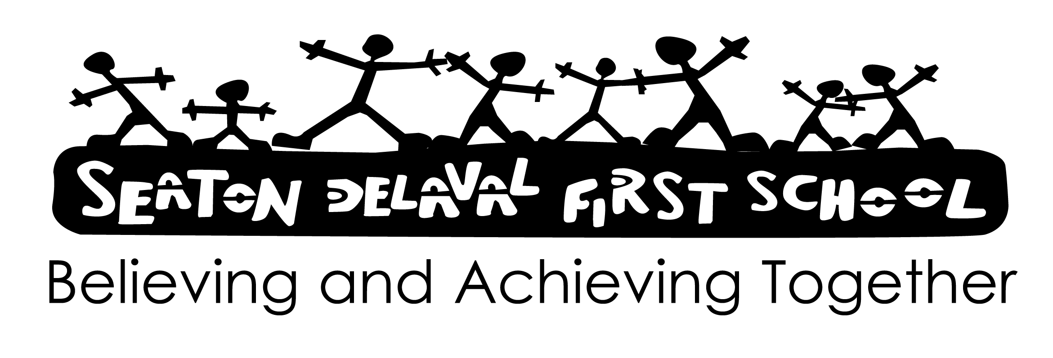

PE and School Sport Policy.

At Seaton Delaval First School we are committed to providing high quality PE and school sport to all our children in a safe and secure environment. Through providing a range of engaging and enjoyable physical activities we aim to promote a healthy lifestyle in school and within the wider community. Through the acquisition and application of motor skills PE and sport helps to promote optimum physical potential by:

- Developing competence and confidence in physical skills, movement, body awareness and body control
- Developing good coordination and efficiency of movement and creative skills by remembering, repeating and refining actions and performing them with increasing control, co-ordination and fluency
- Developing an appreciation of the importance of a healthy and fit body and to begin to understand those factors that affect health and fitness.
- Developing an increasing ability to select, link and apply skills, tactics and compositional ideas

Whilst retaining its unique contribution to pupil’s movement and health education, physical education contributes to all aspects of learning by:

- Developing high levels of attendance, enjoyment, enthusiasm and a strong motivation to get involved in their learning
- Develop the ability to work independently as well as co-operatively and collaboratively by communicating with and responding positively towards others
- Improving observational skills and the ability to describe and make simple judgements on their own and others work and to use their observations and judgements to improve performance
- Promoting an understanding of safe practice, and develop a sense of responsibility towards their own and others’ safety and well-being.

Our school provides all pupils with 2 sessions of high quality Physical Education a week, including specialised sports coaches for KS1 and KS2. The hall and outdoor areas are timetabled during the afternoons to ensure each class has equal access. Units of work are blocked and spread over the year. (See PE curriculum map).

To ensure continuity and progression the school follows the schemes of work provided by The PE HUB for Gymnastics, Dance and Games at Key Stages 1 and 2. Some of the dance units maybe substituted with other dance resources. A long term plan provides teachers with an overview. These units deliver the National Curriculum for Physical Education.
In mixed age classes the children follow the unit of work for the age of the majority of the children in the class but adapt it to meet the needs of the younger/older children.
The PE co-ordinator, in consultation with the Headteacher is responsible for mapping the curriculum and extra curricular sport activities ensuring that the children experience a coherent and progressive curriculum throughout their time in school.

Monitoring and Evaluation
The PE co-ordinator is responsible for overseeing the implementation of the PE curriculum and will observe a selection of lessons the focus of which will depend upon, needs of children, staff development and curriculum reviews etc.

Differentiation and Mastery
Teachers should ensure that planning is differentiated in order to meet the needs of all pupils.
Children should be given sufficient opportunities to apply their learning and deepen their knowledge, skills and understanding in a variety of contexts. Examples of which could include; demonstration, peer coaching, self-assessment and use of appropriate terminology.

Assessment, Recording and Reporting
We use our own assessment to track the progress of individual children to make judgments on whether they are emerging, secure or exceeding. Formative assessment is normally carried out by teachers and other adults in the course of a normal lesson.
The school uses the Clive Davies learning outcomes to arrive at unit levels of achievement.
Assessments are passed to the P.E co-ordinator.
End of Year Reports to Parents report on children’s achievements in and attitudes towards PE.
Children are given the opportunities to assess and comment upon their and their peers achievements and areas for development.

Equal Opportunities and Inclusion (see relevant policy)

Safe Practice
All teachers should make themselves aware of the health and safety arrangements for the areas of activity that they are teaching. The school follows ‘Safe Practices in Education’ guidance as provided by BAALPE which is available to all staff. The PE co-ordinator carries out regular risk assessments of all PE environments using the LEA’s template.
Children will be involved in the movement of apparatus as far as is practical, using correct lifting, carrying and placing techniques as agreed by the teaching staff. Children should only be on the apparatus when directed. It is the responsibility of the teacher to check that all apparatus to be used is safe and secure.
The school has a ‘Dress Code’ for PE and School Sport. (see code)
All adults are CRB checked. When qualified coaches are used to deliver aspects of the PE curriculum their delivery is monitored by the PE co-ordinator and Headteacher.

Staffing
Teachers take their own classes for PE. Teaching Assistants may be asked to support teachers and any outside coaches to deliver the PE curriculum and carry out assessments. All staff take part in professional development to ensure up to date subject knowledge. Staff should indicate where they feel they need support so that the appropriate support can be given by either the subject leader, SSco, etc.

Extra curricular activities
We offer a range of extra curricular activities which are arranged at different times of the year and aim to target these for different year groups to offer equality of opportunity and access.

Cross Curricular Issues
Teachers and pupils make use of technology in order to assess performance. The effects of exercise on the body and related health issues are discussed during PE lessons. In PE poetry and language may be used as a stimulus for Dance and Gymnastic Work. Appropriate music is used for Dance and Gymnastic activities. Children in the early years develop skills in communication and language and personal, social and emotional development.

Resources and Equipment
Resources are stored in the PE store which is in the hall.
The PE co-ordinator maintains and monitors equipment.

Review of Policy: September 2024

Staff: Date:
Governors: Date:

Review Date: September 2026

