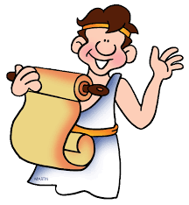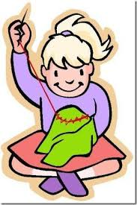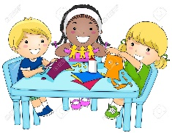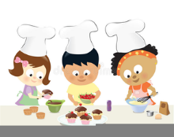

PE Y4

**Games**

Can they hit a ball accurately and with control?

Can they keep possession of the ball?

Can they move to find a space when they are not in possession during a game?

Can they vary tactics and adapt skills according to what is happening?

**Dance**

Can they take the lead when working with a partner or group?

Can they use dance to communicate an idea?

Can they work on their movements and refine them?

Is their dance clear and fluent?

**Cross Curricular Links**

**English**

Playscripts, instructions, story writing.

**Maths**

Weigh& measuring linked to cooking.

Co- ordinates linked to map work.

Angles linked to computing.

Money

**MUSIC**

**Year 4**

Ukuleles with peripatetic teacher

**French Year 4**

**Reading and responding**: Can they read and understand short texts using familiar language? Can they identify and note the main points and give a personal response?

Can they read independently?

Can they use a bilingual dictionary or glossary to look up new words?

**Geography**

**Year 4**

Geographical enquiry

Can they find the same place on a globe and in an atlas?

Can they label the same features on an aerial photograph as on a map?

Can they plan a journey to a place in England?

**DT**

Textiles

Can they join textiles of different types in different ways? Can they choose textiles both for their appearance and also qualities?

Do they think what the user would want when choosing textiles?

Have they thought about how to make their product strong?

Can they devise a template?

Can they explain how to join things in a different way?

**Art**

L.S.Lowry

Knowledge

Can they experiment with different styles which artists have used?

Painting

Can they create all the colours they need?

Can they create mood in their paintings

Do they successfully use shading to create mood and feeling?

Can they organise line, tone, shape and colour to represent figures and forms in movement?

**PSHE**

Year 4

**How do we manage feelings?**

**How can we communicate safely?**

**Internet safety.**

**RE**

**Year 4**

**Hinduism Stories** The importance of Hindu scripture, especially the Ramayana

**Christianity Easter To** know that Easter is important to Christians because it celebrates the resurrection of Jesus though it is preceded by a solemn time when Christians prepare for and reflect on the crucifixion of their founder know that the Bible is the main source for information about Jesus’ crucifixion and resurrection

**Computing Year 4**

**Programming**

•I can use logical thinking to solve an open-ended problem by breaking it up into smaller parts.

•I can use an efficient procedure to simplify a program.

•I can use a sensor to detect a change which can select an action within my program.

•I know that I need to keep testing my program while I am putting it together.

•I can use a variety of tools to create a program.

•I can recognise an error in a program and debug it.

•I recognise that an algorithm will help me to sequence more complex programs.

•I recognise that using algorithms will also help solve problems in other learning such as Maths, Science and Design and Technology.

**Handling Data**

•I can organise data in different ways.

•I can collect data and identify where it could be inaccurate.

•I can plan, create and search a database to answer questions.

•I can choose the best way to present data to my friends.

•I can use a data logger to record and share my readings with my friends.

**Science**

**Year 4 Animals including humans** Can they identify and name the basic parts of the digestive system in humans?

Can they describe the simple functions of the basic parts of the digestive system in humans?

Can they identify the simple function of different types of teeth in humans?

Can they compare the teeth of herbivores and carnivores?

Can they explain what a simple food chain shows?

Can they construct and interpret a variety of food chains, identifying producers, predators and prey?

Exceeding

Can they classify living things and non-living things by a number of characteristics that they have thought of?

Can they explain how people, weather and the environment can affect living things?

Can they explain how certain living things depend on one another to survive?

States of Matter

Can they compare and group materials together, according to whether they are solids, liquids or gases?

Can they explain what happens to materials when they are heated or cooled?

Can they measure or research the temperature at which different materials change state in degrees Celsius?

Can they identify the part that evaporation and condensation has in the water cycle?

Can they explain what happens over time to materials such as puddles on the playground or washing hanging on a line?

**History**

**Year 4**

**Historical enquiry**

Can they research two versions of an event and say how they differ?

Can they research what it was like for a child in a given period from the past and use photographs and illustrations to present their findings?

Can they give more than one reason to support an historical argument?

Can they communicate knowledge and understanding orally and in writing and offer points of view based upon what they have found out?

**Year 4 Topic web**

**The Romans**

**Spring Term**