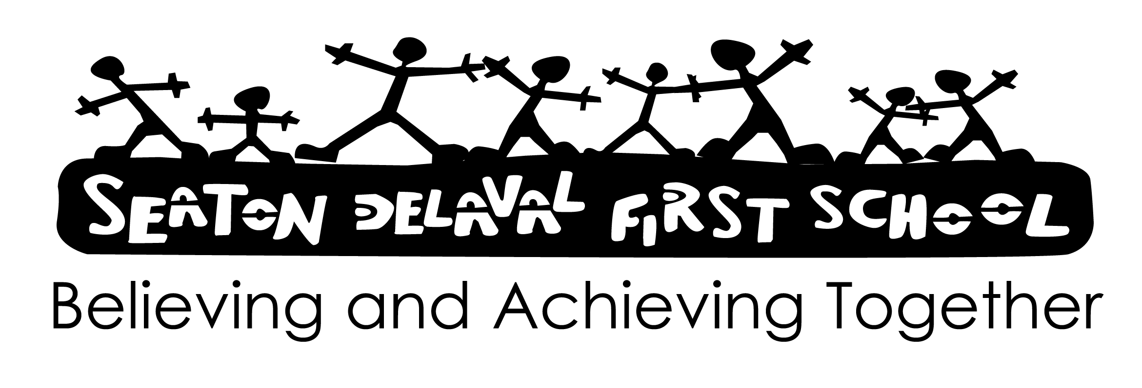

Signed:

Date: June 2024

Review: June 2026

Liaison and Transition

We believe that it is very important to have good liaison to enable schools in different phases to obtain a better understanding of each other's needs and problems and of the way in which each operates. The requirements of the National Curriculum mean that curriculum continuity, assessment procedures, recording and reporting, and the flow of information takes on an increased importance in the transition process.

Aims:
- To forge the best possible links between local Nursery, First, Primary, Middle, High and Secondary schools.
- To make the transition between phases and each Key Stage as smooth as possible for the pupils in our care.
- To maintain regular and annual meetings to discuss various liaison issues.
- To create a common policy for pupil transfer information between phases.

Procedure:
Co-ordinator
- A Liaison Co-ordinator will organise and oversee the school liaison programme.
Liaison Meetings
- Liaison meetings between phases will take place throughout the year.
Moderation Meetings
- It is intended that Y4 teachers of the feeder First Schools meet with Year 5 Middle School teachers in order to moderate pupils work so that a common understanding of levels is formed every half term .
Visits by Teachers
- Prior to their transfer to Upper KS2, the progress of our Y4 pupils is discussed at a meeting between the Y4 teacher and the Head of KS2 of the local Middle School.
Taster Days
- Y2, 3 and 4 pupils are invited to spend several days at the local Middle School in order to give them a real 'taste' of Middle School life.
Nursery-First Transition
- Every effort is made to make the transition from Nursery to the Reception class as easy as possible. This is undertaken by the teachers and nursery nurses in both classes working collaboratively for the Early Years.
First-Middle Transition
- The transition from any First School to the Middle School sector is a very important period in any child's life.
- It is the intention of the school to make this transition as smooth as possible by:-
- arranging times for Y4 pupils to visit the Middle School and to work alongside their Middle School colleagues;
- encouraging continuity in curriculum, teaching styles and classroom organisation;
- and encouraging the staff of the Middle School to visit to discuss pupil's progress.
Inter-School Links
- During the academic year a variety of activities and sporting fixtures are organised with other schools.
Comprehensive Schools
- Students from local High and Secondary Schools undertake work experience weeks in various classes in the school.
Colleges
- Students undertaking courses in NVQ Childcare and NNEB (Nursery Nurses) work mostly in our Early Years as part of their training.
Universities
BA Primary (Hons) and PGCE students undertake their teaching practices in various year groups. A member of staff acts as a school mentor for these students.
Effectiveness
We believe the above strategy is effective in the development of liaison and transition.

