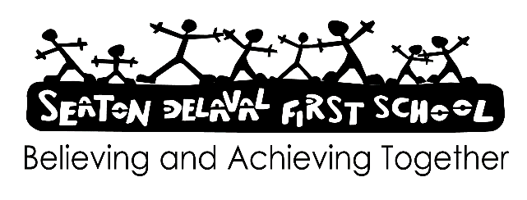

Design & Technology Policy 2024

Design & Technology takes the National Curriculum document as its basis. It is a part of the Early Years Curriculum strands of Expressive Arts and Design and Physical Development, with links to Mathematics, Communication and language and Understanding the world. We believe that all pupils should have access to a broad, balanced, sequential and relevant curriculum.

In the EYFS (Early Years Foundation Stage) DT is integrated into the curriculum daily usually through building or craft activities and from ‘Year One’ upwards, teachers planning and assessment for this subject is based on the National Curriculum document, alongside Clive Davies.

Throughout the school, children participate in activities planned with continuity and progression. Assessment of Design & Technology is both formal and informal depending on the activity. Deeper knowledge and understanding is achieved through a progressive curriculum. Where the children have opportunities to build upon the skills they already have.

Design & Technology activity is concerned with technical knowledge and understanding, designing, making and evaluating. As Design & Technology is a mainly practical subject, the safety of children is always considered. Safety aspects are indicated within each unit of work. Cross curricular links include measurement (Mathematics), discussion (English), the use of electrical circuits (Science), the use of technology to record results and the visual and tactile properties of materials (Art, Computing and Science).

Aims:

EYFS:

* Safely use and explore a variety of materials, tools and techniques, experimenting with colour, design, texture, form and function
* Share their creations, explaining the process they have used
* Make use of props and materials when role playing characters in narratives and stories
* Hold a pencil effectively in preparation for fluent writing –

using the tripod grip in almost all cases

* Use a range of small tools, including scissors, paintbrushes and cutlery
* Begin to show accuracy and care when drawing

The National Curriculum for Design and Technology aims to ensure that all pupils:

• Develop the creative, technical and practical expertise needed to perform everyday tasks confidently and to participate successfully in an increasingly technological world

• Build and apply a repertoire of knowledge, understanding and skills in order to design and make high quality prototypes and products for a wide range of users

• Critique, evaluate and test their ideas and products and the work of others

• Understand and apply the principles of nutrition and learn how to cook