

Signed:

Date: September 2024

Review: September 2026

**Personal, Social, Health and Education (PSHE) Policy**

**Aims and Objectives**

At Seaton Delaval First School, PSHE (Personal, Social, Health and Economic Education) is a planned programme of learning where the children acquire the knowledge, understanding and skills they need to keep themselves healthy and safe. PSHE provides the children with the building blocks in order for them to develop healthy, respectful relationships, focusing on family and friendships, in all contexts, including online. This sits alongside the essential understanding of how to be healthy.

As part of our whole school approach, PSHE develops the qualities and attributes that children need to manage opportunities, challenges and responsibilities as they grow up, enabling them to thrive as individuals, family members and members of society. By teaching pupils to stay safe and healthy, and by building self-esteem, resilience and empathy, our effective PSHE programme enables staff to tackle barriers to learning and raise aspirations for our pupils.

Our PSHE curriculum will be taught through discrete PSHE lessons, as well filtering the skills through out many aspects of school life.

**Statement of intent**

At Seaton Delaval First School, it is our intent to provide **all** children with a broad and balanced curriculum that aims to assist children and young people to prepare for adult life by supporting them through their physical, emotional and moral development, and helping them to understand themselves, respect others and form and sustain healthy relationships**.**

This will be implemented by following The PSHE Association Programme of Work. The two main core themes of our PSHE programme of study focuses on Relationships Education and Health Education. A third core theme, Living in the Wider World is also an integral aspect of our curriculum.

**Relationships Education**

• Families and people who care for me

• Caring friendships

• Respectful relationships

• Online relationships

• Being safe

**Health Education**

• Mental wellbeing

• Internet safety and harms

• Physical health and fitness

• Healthy eating

• Drugs, alcohol and tobacco

• Health and prevention

• Basic first aid

• Changing adolescent body

Department for Education statutory guidance states that from September 2020, all primary schools must deliver relationships and health education whereby parents cannot withdraw their child from this (until this time parents have the consent to withdraw their child from sex education).

**Implementation through Teaching and Learning**

The school seeks to provide a safe, secure learning environment for PSHE that enables children and young people to gain accurate knowledge, develop their own values and attitudes, and develop skills to grow into happy confident successful adults. At the beginning of each year, every class sets ground rules that children must follow during PSHE lessons. This creates a safe and supportive learning environment and allows children to feel comfortable and to speak openly and honestly.

At Seaton Delaval First School we promote the needs and interests of all pupils, irrespective of gender, culture or background and all teachers take into account the children’s age, ability and readiness. PSHE will be provided through discreet curriculum time, assemblies, class discussions/circle time, as and when issues arise, ensuring time is made within the curriculum to meet the needs of the children. We respect pupils’ unique starting points by providing learning that is suitable to their level, taking into account their age, maturity and how emotionally secure they are.

**Early Years and Foundation Stage**

In Early Years, PSED (Personal, Social and Emotional Development) is a prime area of learning therefore an integral aspect of daily planning, teaching and learning.

• Making relationships

• Self-confidence and self-awareness

• Managing feelings and behaviour

Planning is child led to reflect the interests of the children and the needs of the school. Children take part in circle time and discuss topics and themes that are at their level. Teachers look at the three core themes and take aspects of these to inform their planning. PSED is a fundamental building block in a child’s development and underpins the whole curriculum.

**Key Stage One and Two**

Within Key Stage One and Two PSHE lessons are often more structured and follow the scheme of work that is in place. Each class in these Key Stages will follow The PSHE Association Programme of Study. This follows the three core themes which teachers will adapt specifically for the children at Seaton Delaval First School. Children have the opportunity to form and share opinions, value differences, recognise feelings and emotions as well as identify what makes relationships healthy.

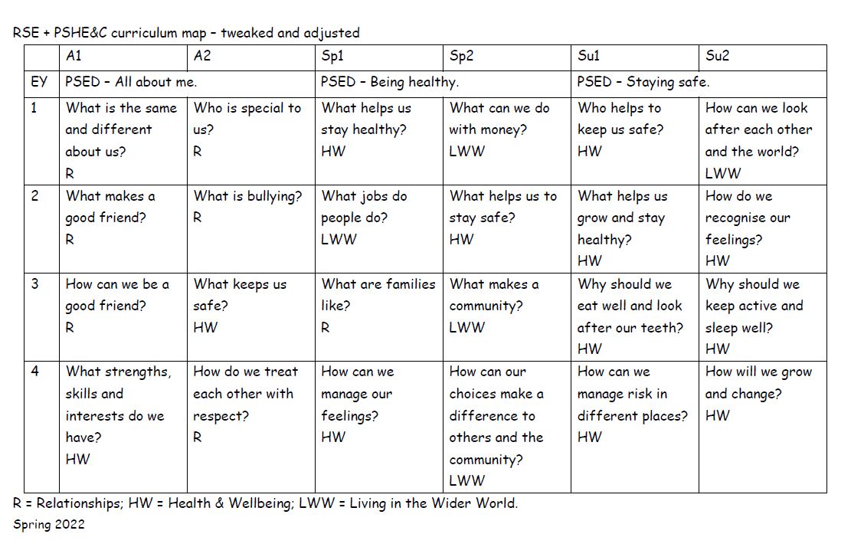

Autumn 2024

**The PSHE Association Key Stage One and Two Long- Term Overview**

**British Values**

As a school we promote British values ensuring that our children leave school prepared for life in modern Britain. We support the values of democracy, rule of law, individual liberty, mutual respect and tolerance of different faiths and beliefs. Through aspects of school life such as voting for school council members, assemblies and discrete PSHE lessons, these values are embedded within our curriculum. We plan assemblies and lessons to teach the children about our values, respecting similarities and differences, tackling stereotypes and understanding why some people discriminate. We aim to empower children to have a voice and to stand up against discrimination, valuing equality, tolerance and mutual respect.

**Implementation through Assessment, Recording, Reporting and Monitoring**

Teachers assess the children’s work in PSHE by making informal judgements as they observe them during lessons. We have clear expectations of what the pupils will know and understand at the end of each year and key stage. Assessment should offer the children the opportunity to reflect on their own progress. Throughout the school, learning will be visible in a number of ways including book work, photos or records of class discussions. The PSHE subject leader is responsible for monitoring the standards of children’s work and the quality of teaching. The subject leader will monitor plans, teaching and learning in order to evaluate strengths and weaknesses in the school and indicate areas for improvement. The subject leader will regularly evaluate the scheme of work to ensure that the needs of the pupils are being met and that there is progression and continuity of learning through the school.

**Implementation through inclusion, including meeting the needs of SEND pupils**

Our teachers provide learning opportunities matched to the individual needs of all children including those with special educational needs and disabilities. PSHE is taught inclusively to all children regardless of their race, religion and gender, whilst at the same time addressing the need for equal opportunity. Staff will ensure that no judgement will be passed on the lifestyles and choices made by others. If a safeguarding issue is raised, staff are required to follow the correct safeguarding procedure and safeguarding policy.

**Implementation through resources**

The PSHE Association provide many websites to access a range of resources for this subject. The PSHE curriculum leader will regularly review resources and obtain, within the constraints of the allocated budget, additional resources as necessary.

**Implementation through Professional Development and Training**

The PSHE subject leader ensures they are kept informed of relevant changes to aspects of PSHE. The subject leader will support colleagues in the teaching of PSHE by giving them information about current developments in the subject and providing a strategic lead and direction for the subject in school.

**Conclusion**

This policy should be read in conjunction with the following school policies:

RSE/ SRE Policy

Drug Policy

Equal Opportunities Policy

Health and Safety Policy

Food Policy

School Travel Plan

Visitors to School Policy

Teaching and Learning Policy

Assessment and Record Keeping Policy

Responding to pupils’ work / Feedback /Marking Policy

ICT/ Computing Policy

Acceptable Use Policies

Online Safety Policy