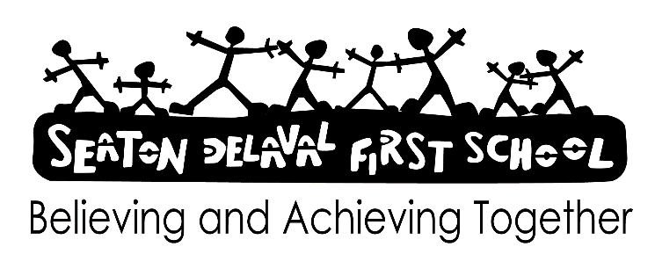

**Signed:**

**Date: July 2024**

**Review: July 2026 [or sooner if required]**

**LGBTQIA+ Policy**

**(Lesbian, Gay, Bisexual, Transgender, Queer, Intersex, Asexual and Plus)**

**Seaton Delaval First School has a duty to safeguard the wellbeing of all pupils in their care.**

**Seaton Delaval First School will not permit the casual use of homophobic language**.

Homophobic bullying/name calling can affect any young person at any time during their education, including primary and secondary schools, as well as Further Education and sixth form colleges.

Any child/adult who uses homophobic language will be challenged, as if unchallenged, a culture of homophobia is created and can impact on young people’s sense of belonging, self-esteem and attainment at school.

All staff will intervene when young people use homophobic language, including the use of the word ‘gay’ to mean inferior. This will create a school culture where homophobia and homophobic bullying is not tolerated.

Homophobic name calling/bullying must be treated in the same way the school challenges any racist language, school staff should feel confident to respond to homophobic language whenever it happens. Anti Bullying staff are available to help all staff if an incident occurs (Mr Flitcroft, Mrs Brown, Mrs Vallely or Miss Brown).

Pupils most affected by homophobic language are;

Pupils who are thought to be lesbian, gay or bisexual.

Boys for behaving/acting ‘like girls’.

Pupils who are openly lesbian, gay or bisexual.

Boys who don’t play sports.

Boys who are academic

Girls for behaving/acting ‘like boys’.

Girls who do play sports.

Pupils who parents/carers/grandparents are gay.

Pupils who have gay friends or family.

**Responding to any homophobic incidents**

Comments such as ‘that’s so gay’ are rarely referring to sexual orientation. *Gay means two people of the same sex being in a relationship.*

Pupils must be taught that it is not a negative thing: that it is hurtful to people who are gay and to young people whose parents and carers, family members or friends are gay.

Any pupil found to be using the term ‘gay’ negatively will be challenged by a member of school staff.

1. A record will be made in the class or lunchtime ‘Behaviour and Safety Yellow folder’ coded “H” [for homophobic] and returned to Headteacher.

2. Children will be removed from the situation and spoken to in more detail about his/her behaviour/language and why it’s offensive.

3. If the child continues to use homophobic language, Senior Leaders must be informed. Involvement and support of the Headteacher and senior management will result in parent/carers being contacted.

4. Parents/carers will be invited into school to discuss the attitude of the child. Leadership team will explain that all pupils should be able to feel safe at school. Parents/carers have an obligation to help school uphold policies.

School staff will be given the confidence and support to challenge homophobic language when it occurs. Seaton Delaval First School will cultivate a culture that discourages the use of homophobic language.

We will involve pupils to make the school a diverse and welcoming place. Involve them in initiatives to promote equality and diversity that including tackling homophobic language and bullying. Pupils can talk to a member of the Anti-Bullying staff, any member of staff or write their concerns and place in the class worry box if they wish to be anonymous.

Specific teaching on issues regarding homophobia will be taught in the same way that school discusses racism and other forms of discrimination. Pupils will be made aware that homophobic language will not be tolerated in school and that there will be sanctions for any child who is found to be using offensive homophobic language.

Homophobic language will be addressed throughout school during PSHE/assemblies and Anti Bullying week activities.

Pupils will be taught to promote equality and encourage peers to view lesbian, gay and bisexual people and their relationships as an equally positive part of society. For example: discussing different families-same love, gay characters in novels, plays or children’s books, civil partnerships and relationship education.

Displays will communicate to pupils positive messages on equality for lesbian, gay and bisexual people.

**Preventative measures are vital in ensuring that school culture is not permissive of such language and that the whole school community understands that homophobic language will not be tolerated.**