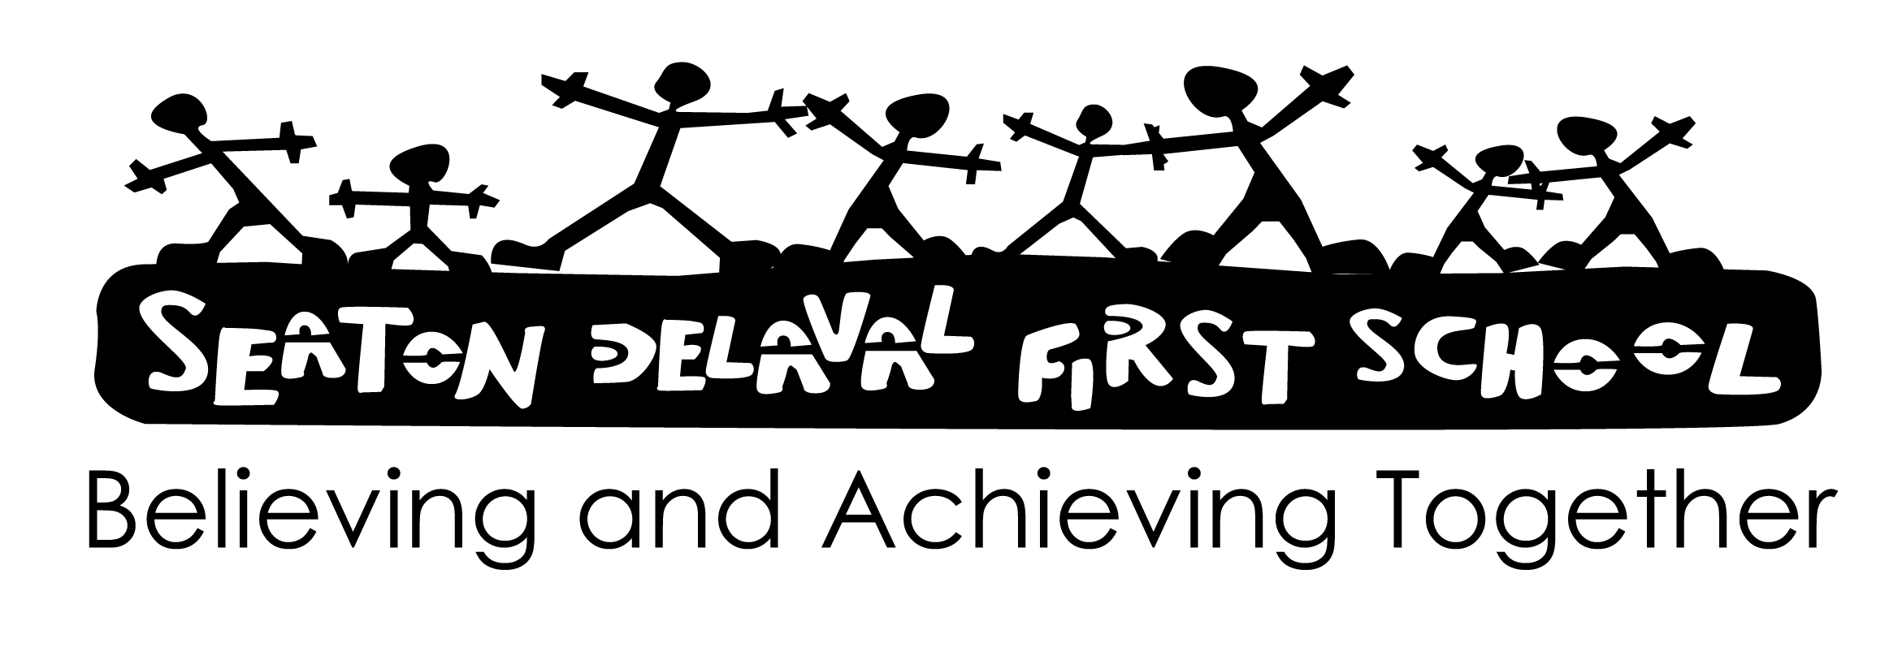

**ART POLICY 2024**

Signed Mrs C Vallely

Chair of Governors

Date September 2024

Review Date September 2026

This policy is consistent with the whole school aims and takes account of the New National Curriculum requirements.

Every child is entitled to receive the best education possible and achieve the highest standards, regardless of ability, disability, gender, social or ethnic background.

To pursue high academic standards through the provision of a broad and balanced curriculum which:

* Serves the needs of all children
* Motivates children to have high expectations and self-esteem
* Stimulates and challenges
* Involves practical and first hand experiences
* Complies with the legal requirements of the National Curriculum and the Early Years Foundation Stage
* Is continuous and progressive
* Has built in monitoring, evaluation and review procedures

We aim to support the teaching of art in Early Years Foundation Stage by:

* Enabling children to explore and experiment with a range of different media and materials.

We aim to support the teaching of art in Key Stage 1 by:

* Enabling pupils to use a range of materials creatively to design and make products
* Using drawing painting and sculpture to develop and share their ideas, experiences and imagination
* Developing a wider range of art and design techniques by using colour, pattern, texture, line, shape, form and space.
* Studying the work of a range of artists, craft makers and designers, describing the differences and similarities between different practices and disciplines, and making links to their own work.

We aim to support the teaching of art in Key Stage 2 by:

* Developing pupil’s techniques, including their control and their use of materials, with experimentation and increasing awareness of different kinds of art, craft and design.
* Creating sketch books to record their observations and use them to review and revisit ideas.
* Enabling them to improve their mastery of art and design techniques, including drawing, painting and sculpture with a range of materials (e.g. pencil, charcoal, paint, clay)
* Studying the greatest artists, architects and designers in history.

**Art Curriculum**

The curriculum consists of seven elements of Art: Form; Shape & Space; Colour; Line; Tone; Pattern. There are seven skills: Drawing; Painting; printing; Collage; Textiles; Sculpture; Digital Media.

Each element is not unique, nor are the skills linked to only one element.

Each year group will focus on a different set of artists to explore the seven elements of art.

Classroom teachers will adjust the focussed artist according to themed topics and will actively encourage the use of a more inclusive set of artists. This will include Male and female artists and artist from multicultural and diverse backgrounds.

**Differentiation**

Activities are differentiated through outcome and levels of support provided as well as through the range of different but related tasks, which are given according to levels of ability.

**Mastery**

Children will be given sufficient opportunities to apply their learning and deepen their knowledge skills and understanding in a variety of contexts.

**Assessment & Record Keeping**

Informal assessment is ongoing with verbal feedback as an integral part of lessons.

Children have art books which tracks progression throughout the school. Each term every child will produce one piece of work to be put into their art books.

* Autumn term (self-portrait)
* Spring term (still life)
* Summer term (own choice)

**Cross-curricular Links**

Wherever possible the Art planned for a term links to other subject areas taught at that time.

**Use of IT**

Children have opportunities to produce their own work using drawing packages such as Jitt on School 360 (see Computing policy and scheme). They also have access to a range of clip art and the internet (with supervision) to find out about artists and view their work.

**Resources/Storage**

Where possible we will also access community links with local artists.

Basic resources e.g. paint/glue are stored in individual classes. A central supply of paper, card and any other resources are stored in the Art cupboard.

We have access to a variety of resources including reproductions of works of Art through the County Loan Scheme as. Some Art books are available in the school library, but again a wider range is available from the County service.

**Evaluation**

This policy and related scheme of work will be evaluated and reviewed annually.